# Setup

1. Ensure all cables are plugged in:
   1. Raspberry Pi
      1. Power cable
      2. Ethernet port connected to ethernet port 4E-052 in Room EB 475
   2. Xmega
      1. Breadboard is connected to 5V power supply
      2. H bridge Vin is connected to 12V power supply and Vout is connected to motors
      3. Encoder cables are plugged into encoders and connected to the breadboard voltage level shifter, per the Xmega pin diagram
   3. Refer to pin layout diagrams to ensure all wires between Xmega and Raspberry Pi are connected properly
2. When Xmega is powered off, both toggle switches should be in the down position
   1. With the black toggle switch near the buttons on the breadboard in the down position, the program will launch directly into “manual positioning mode” when powered on, where the buttons may be used to position the platform
   2. If this toggle switch is left in the up position, the Xmega program will skip “manual positioning mode” and simply wait for input commands from the Raspberry Pi upon power up

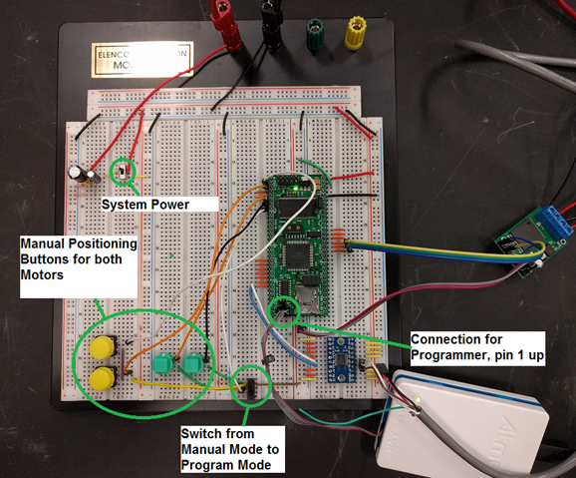

1. Power up Xmega and Raspberry Pi
2. Navigate to beaglebrute.cecs.pdx.edu:443 on a computer connected to the Portland State Maseeh Engineering School’s CECS network.
   1. See The Cat’s guide for VPN: http://cat.pdx.edu/network/vpn-services-in-mcecs-2.html
3. As of June 12, 2017 only one degree of freedom is working on the platform. On the user interface this corresponds to Amplitude 1 and Frequency 1.

# Frequency Input:

1. Xmega
   1. Use the buttons to manually position the platform such that it is perfectly horizontal, as this is the starting position of the platform and be recorded as the zero position on the encoders.
   2. Once confirmed that there are no hazards, and you’re ready to start the program, flip the toggle switch near the buttons from the downward position to upward. The Xmega is now ready for inputs from the RPi.
2. User Interface
   1. Select the desired Amplitude

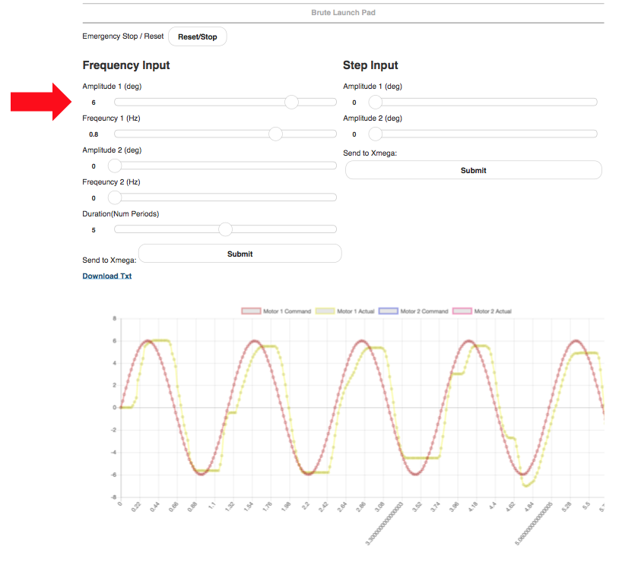

* 1. Select the desired Frequency

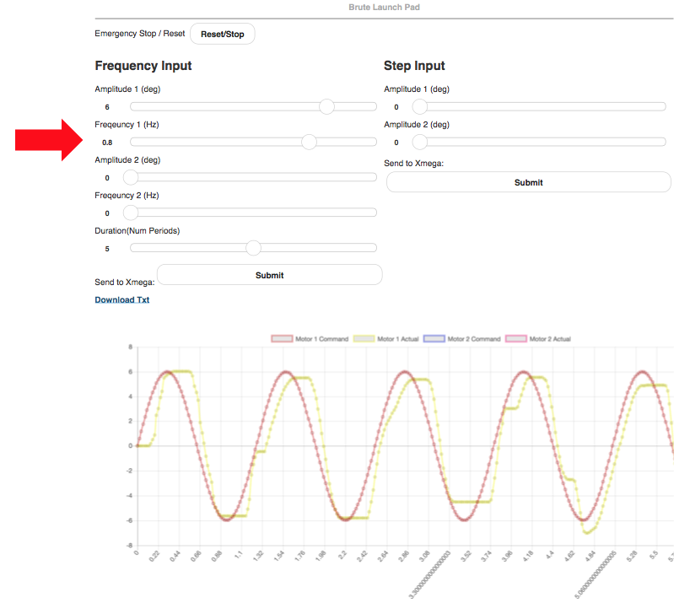

1. Hit the Frequency Submit button

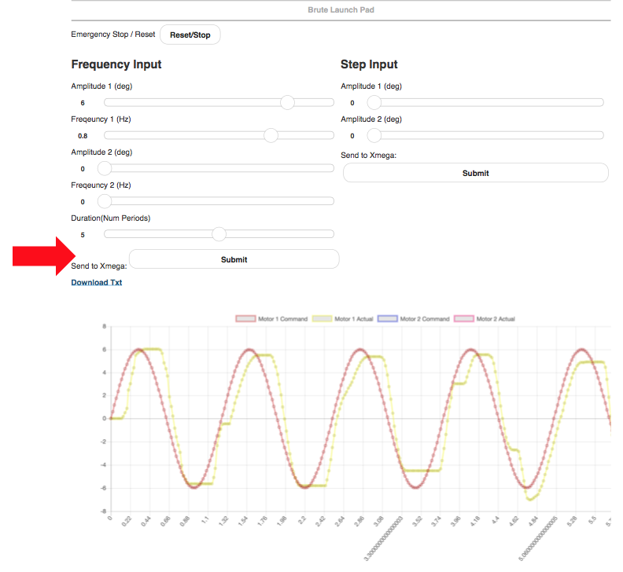

5. To do another trial, wait until the platform has not moved for several seconds then return the lower toggle switch to the upward position. The Xmega program will restart and launch directly into manual position mode. Allow the switch to remain in that position for several seconds before priming it again. Repeat steps 1-4

# Troubleshooting:

1. It’s not working

Sucks bro, Restart everything.

1. I launched the program and the platform slammed into one side and stopped

* Shut it down! (power supply off or Xmega off)
* Make sure you’re getting encoder feedback (check that encoders are plugged in and wires are correctly plugged into the breadboard)
* In repositioning the platform, make sure the linkages are in the correct starting position and have not overshot. The lower link should be near horizontal and the upper link angled toward vertical.

1. I don’t like <X> about the website and want to change it

SSH into the Raspberry Pi using standard ssh terminal using [pi@beaglebrute.cecs.edu](mailto:pi@beaglebrute.cecs.edu), password: raspberry. The website is under /home/pi/Projects at server.js and index.html. SSH file transfer protocol (SFTP) is enabled if you want to edit the files remotely using your preferred SFTP program.

1. I smell burning

Run

1. I want to change the address from beaglebrute.cecs.edu to something else

Contact The CAT.

1. I flipped the lower toggle switch and now the user inputs don’t work

Flip the lower toggle switch to the downward position and reset the Xmega using the upper toggle switch